A User Centered Task Analysis of Interface Requirements for MRI Viewing

J. E. van der Heyden K. M. Inkpen M. S. Atkins M. S. T. Carpendale

School of Computing Science
Simon Fraser University
Burnaby, BC V5A 1S6
{heyden, inkpen, stella, carpenda}@cs.sfu.ca

Abstract
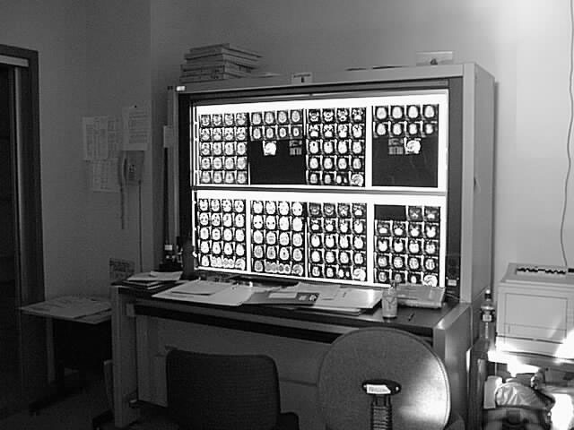
This paper explores the viability of Magnetic Resonance Image (MRI) presentation on a computer screen. This includes investigating the feasibility of presenting the information on a desktop computer in a manner that facilitates MRI analysis and medical diagnosis. Two key objectives are identified: 1) understand the MRI analysis task and determine specific presentation issues and requirements through observations of radiologists; and 2) obtain user feedback on design alternatives. Observations of the MRI analysis task in the traditional light screen environment reveal three requirement categories: user control of films, easy navigation of images and simultaneous availability of detail and context. Design proposals, based on these requirements, include the use of windowing techniques, workspace and overview design, and detail-in-context concepts, as well as the adoption of metaphor and structure from the traditional light screen environment. The results from the preliminary user feedback support the value and feasibility of providing MRI analysis on a computer screen.

Key words: User interfaces, user-centered task analysis, MRI viewing, health care, medical images, screen real estate problem, detail-in-context.

Introduction
Computer technology plays an important role in many disciplines, aiding human specialists with the management, analysis and manipulation of information. The area of medicine is no exception and there is currently a great deal of interest in Hospital Information Systems (HIS), Radiology Information Systems (RIS), Computer Aided Surgery (CAS) and Computer Aided Radiology (CAR). Many medical information management tasks, diagnostic tasks, and surgical activities are now facilitated or even performed by computers. With the large number of highly specialized tasks found in areas of medicine, many have unique user interface as well as technical requirements. One of these tasks, radiology, and more specifically, the viewing of Magnetic Resonance Images (MRI), presents interesting user interface issues. Utilizing the computer for MRI analysis tasks involves displaying digital MR image sets on the computer screen instead of MR image films on a traditional light screen (see Figure 1). This is sometimes referred to as “going filmless” as it involves replacing film by digital computer images. This also means that the same criteria currently met by a very large light screen display, must also be met by a much smaller computer screen. This type of challenge has arisen in other application domains and is often referred to as the “screen real state” problem.
Figure 1. The traditional light screen used by radiologists to display MR images.

Motivation and objectives
The current emphasis on shifting from the traditional film-oriented environment to computerized image viewing is motivated by several factors. The desire to exchange images among hospital departments and between remote locations, the potential of computerized medical image display systems to assist with image analysis, and the need to overcome long-terms health problems resulting from prolonged exposure to films, have all contributed to the transition. While the shift to digitized images appears inevitable, the user interface of these systems is often neglected since current systems focus primarily on image processing rather than image presentation. In particular the presentation of images and image sets in a manner that provides the same advantages as the light screen remains a difficult problem. The light screen is capable of presenting all images in full size and at the same time. This ability to display both detailed and contextual information at the same time is difficult to obtain on the computer screen, as screen size is limited. Medical image modalities, such as MRI, which involve image volume sets, are especially susceptible to this issue as they involve a large number of inter-related images.
This paper explores issues related to the feasibility of conducting MRI analysis tasks on a computer screen and the usefulness of specific design directions. Two key objectives were identified. The first objective was to understand the MRI analysis task and determine specific MRI presentation issues. The second objective was to identify initial design directions and obtain user feedback on these approaches.

Related Work

The screen real estate problem
The screen real estate problem can be described as the problem of presenting information within the space available on a computer screen. Typically the desired information must be compressed, abstracted, or otherwise distorted to fit into the relatively small area. The problem is common to many different applications and solutions vary depending on the domain requirements. Elements of database, visualization, graph layout theory and HCI literature all offer insight to different aspects of this problem.
Common to all aspects of the screen real estate problem is the issue of providing contextual information at the same time that essential detailed information is also provided. Detail-in-context techniques are used to emphasize some given information and de-emphasize or distort the rest of the information. Scaling and abstraction are common emphasis techniques. Scaling is used to enlarge detail and shrink context while abstraction, especially in the form of filtering and hierarchical clustering can selectively hide contextual data thus allowing more space for the detailed data. Early detail-in-context techniques provided one item of interest (focal point) with full detail, while the remaining items were distorted in some manner to fit the remaining space [18, 12, 9]. While these early techniques allowed only one focal point, most current approaches allow multiple focal points. Other approaches include the use of clustering techniques [1, 7, 16, 19], graph structures (see [14] for survey), radial magnification [4], and continuous zoom [2,7]. Some approaches [12, 13, 17] distort shape and relative size, while others [7, 19] do not. See [5, 10, 13, 14] for full details of taxonomy, comparison, and discussions of distorted presentation techniques.

Medical imaging viewing
Picture Archiving and Communications Systems (PACS) are systems that deal, in general, with all aspects of the transmission, storage, processing and display of sets of digital image files. All PACS require some facility for presenting one or more images which may provide insight into image presentation techniques.
For applications where generally only one image is examined at a time sub-windows are often used to display relevant versions or portions of the image [20, 3, 8]. Sub-windows are also used to display related images or display different planar views and 3D-volume rendering [3]. Sub-windows can be coupled so that user action in one is reflected in the others [20]. Volume sets of images (as in MRI) are generally presented in two layouts, tiled and stacked. In tiled mode it may be necessary to use scrolling techniques [11] in order to view all of the images if there are too many. In stacked mode, consecutive 2D slices can be stacked over each other to produce a so-called “cine” mode [15], where a 3D volume of 2D slices is viewed in succession in an animated manner.
All systems reviewed use some form of magnification but many restrict this function to system-defined values and increments [6, 24]. Beyond 2D presentations of images, 3D rendering [15, 3, 8] and 3D reconstruction [15, 3] are also used for viewing and browsing. None of the systems investigated maintain the context of the images on the screen while magnifying a specified image or portion.

Initial User Observations
A task-centered design approach was taken to observe and understand real representative tasks pertaining to the analysis of MR images. A series of informal discussions with radiologists and observations of their work with MRI provided insight into the traditional light screen environment as well as the analysis process used by the radiologists.

Background
The light screen panel used in this study consists of two visible screens positioned one above the other to form a 58” Χ 38” display area (see Figure 1). Displaying MR images using this traditional technology allows up to eight MRI Films to be placed on the visible screens where each film measures 14” Χ 17” and contains 15 to 20 images depending on image size and shape. Other screens may also be loaded with images but are hidden from the display and must be moved into the lighted area to be viewed.
MR image sets are large because they are made up of various dimensions which combine to create different image types. First, MR images are tomographic. That is, they come in sets of slices that together represent a volume (i.e. third dimension). This is significant because it means that a key aspect of MR image viewing is the visualization of the 3D volume as represented by the slice set. In a traditional film oriented environment, this is done in the minds of the radiologists, who can mentally envision the transition between each of the slices. Any complete set of MR slices will further be referred to as a volume set. Secondly, MR image groups consist of images of various planar orientations. This means that volume sets can contain slices as viewed from top to bottom (axial), left to right (sagittal) or back to front (coronal). Finally, volume sets can also differ by way of contrast. During image acquisition, parameters can be manipulated to change pulse sequences and resulting image contrast. These contrasts reveal different tissue types and anomalies using varying grey scale intensity levels and are an important factor in the identification of healthy and unhealthy tissue. For a more detailed description of these image types see [21].

Field observations
A field study was conducted at Vancouver Hospital to understand the MRI analysis process. Informal observations of five radiologists interacting in a traditional film-oriented environment were gathered over an eight-week period using researcher field-notes and videotape data. Observations were gathered during five one-hour diagnostic teaching sessions involving both intern and staff radiologists. Question and answer sessions were also conducted with the radiologists following the diagnostic sessions to better understand the nature of the images and the diagnostic process.
Films are initially arranged on the light screen (Figure 1) by the radiologist in training who arrives first and makes an initial interpretation. The staff radiologist arrives later to lead the final analyses. Usually the images related to one MR case study fit on two screens and thus are viewed as one continuous display area but occasionally more than two screens are required to display the images. As the entire area allows only two screens to be displayed at any one time, additional screens are not visible until they are brought into view by a mechanism that slides the screen panels up and down as required. However, images do not necessarily occupy the whole space and in some cases they may occupy a single screen or less. Films are arranged according to volume sets where appropriate or according to individual preference. Films from different studies are sometimes included in the case, such as historical images for reference. Some films may also be initially excluded as not relevant.
The observations gathered from the researcher field-notes are summarized in Table 1, column 1.

Discussion
We have seen that MRI analysis is unique in that, among other things, a MRI study contains a large and complex set of images. This is because a MR image case study involves various subsets of images with inter-relations which are important to the diagnostic analysis. Radiologists search for many types of anomalies both within an image and across related images. At the same time, comparisons among slices involve transitions from one slice to the next comparing to the “norm” in order to locate unhealthy anomalies. Sometimes, symmetry is also used in this comparison to the norm. Planar views are used to fill gaps and provide a “whole picture”. Often, all of the comparisons are necessary in order to obtain a final diagnosis.
Observations and discussions reveal that all images are scanned at least once and several subgroups of images are highlighted for simultaneous viewing and comparison purposes. Permanently positioning films into sub-group clusters is not feasible since some images are used in multiple sub-groups. Radiologists solve this problem by dynamically reorganizing the films when needed or physically moving around the display space to view the disconnected images. Although this method appears cumbersome, it allows radiologists complete control and flexibility with regard to which images they view up close, which images they view as a group and which image sets they scan as a whole. Further examination of the observations and comments from the radiologists resulted in identification of tasks and associated requirements (shown in Table 1, columns 2 and 3).
The requirements can be grouped into three main categories: control, navigation, and detail-in-context.
- Control: Provide flexible user control over the location, size, visibility and membership of groups. This includes the ability to interactively create user-defined image groups from non-sequential images and to control group location, visibility and display size.
- Navigation: Ability to locate and relocate images as well as groups of images. This involves the user knowing where to find an image or image group that is of current interest.
- Detail-in-context: Ability to view one or more images (image groups) up close while still viewing the remaining images. This includes the ability to present individual image detail and related contextual images at the same time without enlarging the space occupied by the specified group.

Table 1. User Observations and Associated Tasks and Requirements.
# | Observations | Tasks | Requirements
1 | Placing films on the light screen. | Set-up films for viewing. | Ability to choose films and film position for the session from the current case study.
2 | Moving from top to bottom, right to left, of the light screen to view every image. | Scan all images. | Ability to view all films in the presentation simultaneously.
3 | Pointing at images from different areas of the light screen. | Select images from different volume sets. | Ability to find and select images from any volume set.
4 | Pointing at specific areas within an image, examining and sometimes measuring the areas. | Examine images closely. | Ability to view an image up close.
5 | Pointing at an image while examining other images and returning periodically to the reference image. | Mark an image for future reference. | Ability to locate, relocate and mark images
6 | Pointing at several images one by one repeatedly and examining each individually in sequence. | Compare multiple images. | Ability to group related images from different films.
6 |  | Compare multiple images. | Ability to view some images in user created groups up close without losing sight of the rest of the images in the group.
7 | Sweeping hand motion across an entire film especially in the initial stages of viewing. | Interpret a film as a volume. | Ability to view a volume set as a group with adequate detail.
8 | Moving light panels up and down to bring images closer to the viewer. | View images up close. | Ability to view groups of images up close.
9 | Moving films to a different location for better grouping and context during consultation. | Group films. | Ability to control relative position of films during session.
10 | Holding film up to light panel. | View images up close. | Ability to view one or more images up close without losing sight of other images in the set or losing sight of other volume sets.
11 | Removing films from the light panel. | Clear space in the display area. | Ability to control information hiding.
12 | Adding films for additional information. | Add supplementary information during consultation. | Ability to add films to the session while it is ongoing.
13 | Returning to view previously selected images multiple times. | Revisit image groups for more detailed inspection. | Ability to locate and relocate groups of images.

Initial Design Solution
The information gathered by the related work and the initial observations were combined to create an initial design approach to address the three requirement categories: Control, Navigation and Detail-in-Context. The common approach to computerized image presentation is to provide an anchored display area in which a number of images are displayed. This approach is fairly rigid and does not provide the user with much control over image sequence, position or context. For example, if the user chooses four images per display, the images will appear sequentially in the display area four at a time. The user cannot position, group, hide or enlarge images as desired, and the sequence of the group cannot be changed. The display area also suffers from the detail-in-context problem. That is, if a large number of images are chosen for simultaneous display, the images may appear too small for diagnostic viewing, in contrast, when a small number of images are chosen (resulting in larger images) context is lost. This problem is often addressed by scrolling, panning and coupled windows. These methods all require a shift of focus on the part of the user and this cognitive chore can be disruptive and especially undesirable when comparison of images is crucial for medical diagnosis. Five design directions were chosen to overcome these shortcomings and satisfy the design requirements identified from the initial user observations: Metaphor, Structure, Windowing, Workspace and Detail-in-Context.
- Use the light screen environment as a metaphor. Many desirable features are inherent in the light screen environment and we can take advantage of these. Furthermore the knowledge and familiarity that radiologists already have from the light screen environment can be utilized, making the transition to the computer screen, easier and faster.
- Adapt the existing MRI structure to the presentation. A structure is already inherent in the image data by way of image types, films and case studies and can be adopted by the computer interface with minor modifications. As much as possible, terms that are familiar to the original structure are used.
- Use windowing techniques to provide control and flexibility. This addresses the Control requirements as windows can easily be adapted to incorporate desirable interactive grouping features. Films, which represent volume sets, are placed in widows to achieve user control of location, size and visibility components. Figure 2(a) shows six films set up and ready for viewing. Each film has been placed in a window and can be moved, resized, closed or iconized. Figure 2(b) demonstrates a film being enlarged. Users can also create user-defined image groups by placing individual images into an empty window (see Figure 3(a) - (c)). Links are maintained between selected images and their “home” locations in order to provide overall orientation of the images in the films.
- Use the workspace concept to provide easy access to film overviews. This addresses the Navigation requirements by organizing the work area and facilitating navigation of films. Workspaces and overviews are defined to represent either the full case study or a subset of the study used in a working analysis session.
- Use detail-in-context (distortion) techniques to provide flexible image layouts which do not sacrifice contextual information. This addresses the Detail-in-Context requirements by selecting one or more “focal” images for enlargement and shrinking the remaining images so they remain visible but fit in the limited space. Initial criteria and resulting detail-in-context layout approaches are introduced in [22] while [23] provides a closer examination of the detail-and-context requirements.

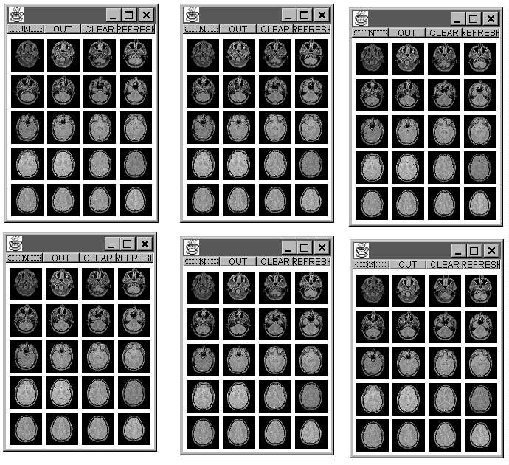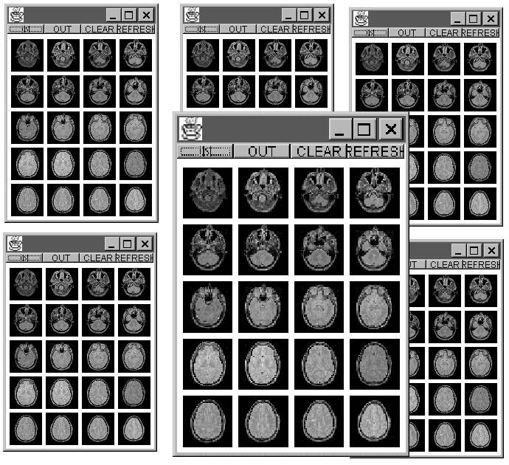
(a) (b)
Figure 2. Volume Films as windows
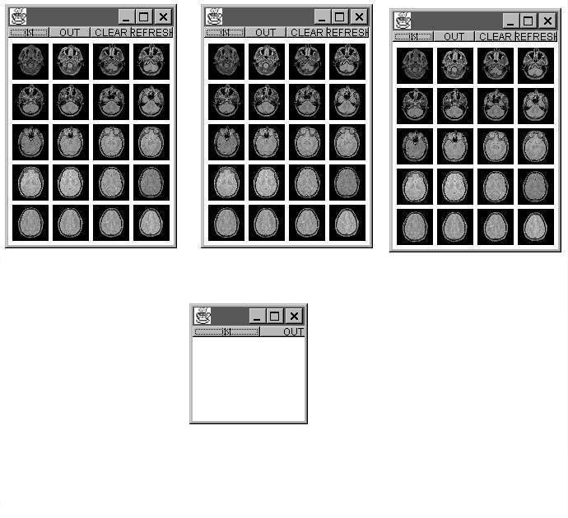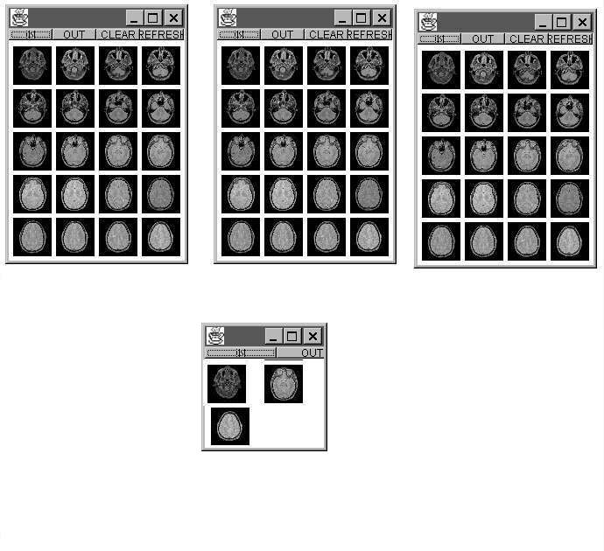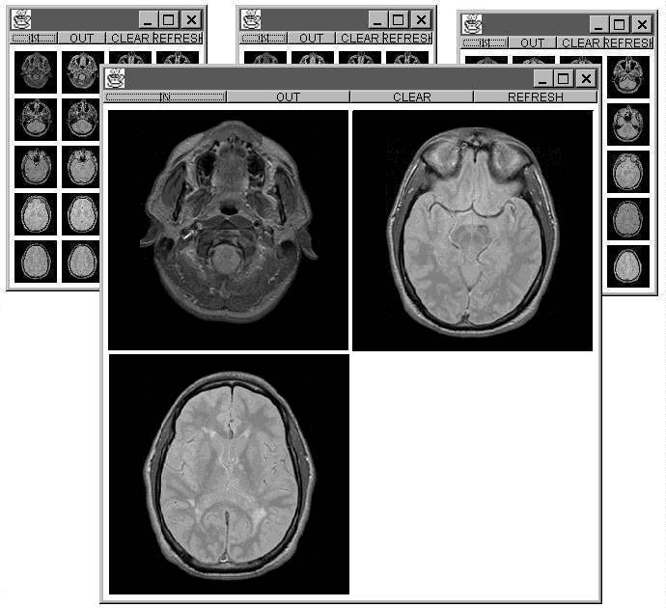
(a) (b) (c)

Figure 3. Creating and enlarging a User-defined Group.

Preliminary User Feedback
A user feedback study was conducted to address some of the issues uncovered from the initial user observations to guide the future design directions of MRI presentation on the computer screen. The study was designed to determine the validity of the proposed design directions as well as obtain specific user feedback on issues concerning the usefulness of film overviews, user control, and presentation of both detail and contextual information.

Method
The study took place at the Vancouver General Hospital, University of British Columbia (UBC) site in the spring of 1998. Three radiologists, all male, participated in the study. All three participants work with MRI and were available for MRI diagnostic consultation at the hospital. It was difficult to find expert participants (radiologists) who could afford the time and were willing to participate in the study. Due to the small number of participants the information is considered informally, serving only to indicate possible acceptance of current concepts and directions for further work.
The researcher met separately on different days with each radiologist. Sessions lasted from 30 to 60 minutes. Participants were given answer sheets which listed question numbers but not questions, and provided additional space for comments. Questions were given verbally by the researcher from a written questionnaire. By asking the questions verbally, it was possible to provide further explanation and assess whether the questions had been understood. This was necessary because radiologists were unfamiliar with computer concepts such as windowing and detail-in-context layouts especially within the context of MRI. Additional clarification was also provided if requested by the participant.
Issues investigated in this study relate to the feasibility and usefulness of MRI presentation on a computer screen related to the requirements outlined from the initial user observations. It was necessary to determine whether certain design directions would be useful to the radiologists and usable in a MRI analysis task. Feasibility was addressed by examining the minimum image size needed for different viewing purposes and the number of films containing volume sets desired on the display surface. User control was examined through radiologists' preference ranking of film manipulation (select, move and magnify) and user-defined image group creation and manipulation. The appropriateness of navigation issues, such as a volume set overview, and the desire to provide detail-in-context were both evaluated through radiologists' ranking.

Discussions
Feasibility
Before delving into various presentation strategies to provide both local detail information and global context within a display, it was necessary to determine whether images smaller than normal size would be useful to the radiologists. The task of MRI analysis is extremely sensitive and misleading information cannot be tolerated. Radiologists were asked to specify the minimum image size that was acceptable for three types of analysis tasks: distinguishing between volume sets; distinguishing between slices; and for diagnostic purposes. The participants were given a series of seventeen MR brain image sets ranging from 25 pixels to 256 pixels (full size) and instructed to indicate the minimum size that would fulfill the specified requirements. Table 2 summarizes minimum image sizes selected by the radiologists for each criterion.
Table 2. Minimal size of images to distinguish between criteria.
Distinguishing between  Volume Sets | Distinguishing between  Slices | Diagnostic
25 - 45 pixels | 35 - 115 pixels | Full size  (256 pixels)
As expected, all the radiologists agreed that full size images were necessary for diagnostic tasks. Interestingly though, for other peripheral tasks such as distinguishing between volume sets and distinguishing between slices, the minimum sizes specified are substantially smaller than full size (25 - 45 pixels squared).
While the image size results indicate the feasibility of placing multiple images on the display, it is also important to address whether the radiologists would find it useful to be able to view an overview of some or all of the volume films simultaneously on the screen. Table 3 shows the radiologists ranking with respect to the usefulness of volume set overviews. The ranking scales ranged from 1 to 4 with 1 corresponding to not useful and 4 to most useful.
Table 3. Overall usefulness of user control features: rankings from 1 (not useful) to 4 (most useful).
Participant | Volume Set overview
#1 | 3
#2 | 2
#3 | 4
Average | 3
Given the usefulness of a volume set overview, to fully address the issue of feasibility, we need to determine the number of volume sets desired by the radiologists. For example, we need to know whether a radiologist would find a feasible overview (one that fits on a computer screen) useful. Ten sets of volume sets of 20 images at 256 pixels each might be very useful but not feasible. Table 4 shows the desired numbers of volume sets in an overview by two criteria: film slices that are distinguishable and images that are at diagnostic size. The participants were asked to provide a range rather than just a number.
The results affirmed that having some or all volume sets on the screen at one time is desirable as long as they are distinguishable from each other. Participants also indicated that it would be useful to have more than one volume set of full size images. Combined with the information gathered concerning image sizes, and volume set overviews, these results establish the feasibility and potential usefulness of presenting several volume sets on a single display.
Table 4. Number of volume sets desired in an overview
Participant | Number of volume sets desired  (films distinguishable from each other) | Number of volume sets desired  (films diagnostic (full) size)
#1 | All | 2
#2 | 1 – 2 | 4 – 8
#3 | 4 – 8 | 4 – 8
User Control
One of the key requirements identified from the initial user observations was user control. The traditional light screen environment provided some user control since it enabled films to be removed from the display and reorganized. Other control however was difficult such as the magnification of individual films or the clustering of images distributed across films. Radiologists’ preferences for various control aspects were solicited through numerical rankings. The participants were shown figures to illustrate the concepts that were being ranked. These concepts included the ability to select, move, and magnify films and the ability to create user-defined groups comprised of images from various volume films. The ranking scales ranged from 1 to 4 with 1 corresponding to not useful and 4 to most useful. Table 5 shows the radiologists’ ranking for each criterion.
Table 5. Overall usefulness of user control features: rankings from 1 (not useful) to 4 (most useful).
Participant | Ability to select move, and magnify films | Ability to create user-defined groups
#1 | 3 | 4
#2 | 4 | 2
#2 | 4 | 4
Average | 3.66 | 3.33
All three radiologists agreed that user control over films was important for the MRI analysis task. Two of the three also indicated a strong preference for the ability to create user-defined groups of films. These results confirm our hypothesis from the initial user observations that user control would be both desirable and useful.
If we were going to provide the radiologists with user-defined groups, it was necessary to know how many images they would want to place within the group. Table 6 shows the ranges given by the radiologists.
Table 6. Number of images radiologists would desire in a user-defined group.
Participant | Number of images in a user-defined group
#1 | 3 – 4
#2 | 1 – 4
#3 | 4 – 8
These results indicate that the user-defined groups might have anywhere from 1 to 8 images. This is encouraging as it verifies that the concept of user-defined groups is useful one and that the radiologists can foresee choosing a number of images out of their regular sequence.
Detail-in-Context
The ability to view one or more images (or image groups) up close without losing the remaining images was also assessed by having the radiologists’ rank their preference on a scale from 1 to 4 with 1 corresponding to not useful and 4 to most useful. Table 7 shows the results of the radiologists’ rankings. All three radiologists agreed that this would be a useful feature for the MRI analysis task.
Table 7. Overall usefulness of detail-in-context: rankings from 1 (not useful) to 4 (most useful).
Participant | Detail-in-Context
#1 | 4
#2 | 3
#3 | 4
Average | 3.66
The detail-in-context aspect of the design involved a number of specific criteria and several initial approaches [21, 22]. [23] discusses a more detailed investigation of these issues and layout criteria tradeoffs.

Conclusion and Future Work
This paper explored presentation of Magnetic Resonance Images (MRI) on a computer screen, focusing on the requirements dictated by the current state of MRI analysis and the feasibility and usefulness of such approaches in a computerized environment. Observations of the MRI analysis task in the traditional light screen environment, resulted in a better understanding of image presentation issues and requirements. It was found that these requirements reflected the strengths provided by the light screen. In particular the strengths included user control of films, easy navigation of images and simultaneous availability of detail and context. General design directions identified the display environment metaphor and structure as well as addressed the requirement issues. Metaphor and structure were adopted from the traditional light screen environment while windowing, workspace and detail-in-context concepts and methods were incorporated to resolve requirements.
Albeit preliminary, the user feedback results provide positive indications that the suggested design directions are both feasible in a standard computerized environment and useful for the MRI analysis task. In particular, images less than full size were shown to be useful in some contexts and this combined with the number of films that radiologists desire on the screen at any given time, provides a feasible solution for desktop computer systems. The value of user control identified in the initial observations was reinforced through user feedback with respect to film manipulation and the ability to create user-defined image groups. Provisions for detail-in-context were also reaffirmed from the user feedback. If contextual and even some distinguishing information can be provided by images which are ten to twenty percent of the full sized image, then it becomes feasible in practice to control areas of detail and context in order to successfully present images on the computer screen while minimizing the loss of the advantages associated with the much larger light screen.
The results described in this paper highlight important issues with respect to MRI analysis on computer screens. The task-centered focus of our approach is essential for the development of systems that are both usable and useful. Future work will involve more iterations of design and user feedback. Detail-in-context layout algorithms are continuing to be explored and obtaining user feedback on these layouts is the obvious next step. It is also necessary to develop a functioning prototype to gather more accurate assessments of the design directions proposed and allow radiologists to become more comfortable with the concepts.

References
[1] Asahi T., Turo D.,Shneiderman B., Visual decision-making: Using treemaps for the analytic hierarchy process., ACM CHI 95, Conference Companian, Denver Colorado, May 7-11, 1995, 405-406.
[2] Bartram L., Ho A., Dill J., Henigman F., The continuos zoom: A constrained fisheye technique for viewing and navigating large infomration spaces., UIST’95, November 14-17, p. 207-215, 1995.
[3] Bitti M.G., Matta G., Tuveri M., Zpaddeu G., Pescosolido M., Pili P., Scheinine A., Zanetti G., Proceedings CAR' 96, 1996, 345-350.
[4] Carpendale M. S. T., Cowperthwaite D. J., Fracchia F. D., 3-dimensional pliable surfaces: For effective presentation of visual information. UIST'95: Proceedings of the ACM Symposium on User Interface Software and Technology, 217-226, ACM press, 1995.
[5] Carpendale M. S. T., Cowperthwaite D. J. , Storey M.-A. D., Fracchia F. D., Exploring Distinct Aspects of the distortion Viewing Paradigm, TechReport-U-SFraser-CMPT-TR:1997-08, 1997.
[6] Cho S., Kim K., Choi H. S., Park H., Personal medical information system using laser card., Proceedings SPIE, Image Display, 1996, 419-430.
[7] Dill J., Bartram L., Ho A., Henigman F., A continuously variable zoom for navigating large heirarchical networks., Proceedings of International Conference on Systems, Man and Cybernetics, 386-390,October 1994. IEEE
[8] Frithjof K., Gabriele L., BRAIN (Brain Image Analysis) - A toolkit for the analysis of multimodal brain datasets., Proceedings CAR' 96, 1996, p. 323.
[9] Furnas G. W., Generalized fisheye views. Proceedings of CHI'86, Boston, MA-1986, 16-34.
[10] Leung Y. K., Apperley M.D. A review and taxonomy of distortion-oriented presentation technigues., ACM Transactions on Computer-Human Interaction, Vol 1, No. 2, June 1994, 126-160.
[11] Lidier Y., Ratib O., Girard C., Logean M., Trayser G., Distributed file management for remote clinical image viewing stations., Proceedings SPIE, PACS, 1996, 475-482.
[12] Mackinlay J. D., Robertson G. G.,Card S. K., The perspective wall; detail and context smoothly integrated, ACM, Proc. CHI'91, 173-179.
[13] Misue K., Eades P., Lai W., Sugiyama K., Layout Adjustment and the Mental Map., technical Report IIS-RR-94-1E Fujitsu Laboratories.
[14] Noik E. G., A space of presentation emphasis techniques for visualizing graphs., Graphic Interface, 1994.
[15] OSIRIS on line User Manual Version 2.5, http://expasy.hcuge.ch/www/UIN/html1/projects/osirs/osirismanual.html [retrieved Aug. 29, 1997] , 1995.
[16] Robertson G.G., Mackinlay J.D., Card S.K., Cone trees: Animated 3D visualizations of hierarchical information., proceedings ACM Conference on Human-Computer Interaction:CHI'91, 189-194, 1991.
[17] Sarker M., Snibbe S. S., Tversky O. J., Reiss S. P., Stretching the Rubber Sheet: A Metaphor for Viewing Large Layouts on Small Screens, UIST’93, Nov. 3-5, 81 - 91, 1993.
[18] Spence R., Apperley M., Data base navigation: an office environment for the professional., Behavior and InformationTechnology, 1(1), 1982, 43-54.
[19] Storey M.D., Muller H.A., Graph Layout Adjustment Strategies., Graphing =[yu76
[20] Tao E. Y., Sklansky J., Analysis of mammograms aided by database of images of calcifications and textures., Proceedings SPIE, Image Processing, 1996, 988-995.
[21] van der Heyden J. E., Magnetic resonance image viewing and the “Screen real estate problem”., Msc. Thesis, Simon Fraser University, 1998.
[22] van der Heyden J.E., Carpendale M.S.T., Inkpen K., Atkins M.S., Visual Representation of Magnetic Resonance Images, Proceedings Vis98. 1998, 423-426.
[23] van der Heyden E.J., Atkins M.S., Inkpen K., Carpendale M.S.T., MR image viewing and the “Screen real estate problem”, Proceedings Medical Imaging, SPIE99, 1999.
[24] Wong S. TC, Whaley P., Ang CS, Soo Hoo K., Wang J., Huang HK, Interactive query and visualization of medical images on the world wide web. Proceedings SPIE, Image Display, 1996, 390-401.

