Evaluation of the spatial normalization of brain images

Carol Lane §, Stella Atkins∗ and Peter Liddle §

§ Department of Psychiatry, University of British Columbia, 2255 Wesbrook Mall, Vancouver, BC V6T 2A1, Canada. Email lanec@unixg.ubc.ca; liddle@interchange.ubc.ca

∗ School of Computing Science, Simon Fraser University, Burnaby, BC V5A 1S6, Canada. Email: stella@cs.sfu.ca

Note: Author for correspondence: Stella Atkins, School of Computing Science, Simon Fraser University, Burnaby, BC V5A 1S6, Canada.
Tel: (604) 291 4288
FAX: (604) 291 3045

Abstract

Several methods are available for spatially normalising, or registering, subject brain images to a template brain image for statistical studies. We examine five methods based on two alternative approaches for image registration using positron emission tomography (PET) and Magnetic Resonance (MR) brain images, and describe a new method, called voxel concordance, for evaluating the accuracy of these methods.

In this paper we describe two methods used to achieve spatial normalisation based on rigid linear transforms, and three methods based on non-linear or warping transforms. Two methods use the subject’s MR image as a basis for registration to an MRI template image, and three methods use the PET data directly.

The new evaluation method is based on the idea that in a good registration, the voxels corresponding to gray matter should have a high degree of concordance, as should the non-gray voxels. It is assumed that the higher the degree of concordance, the better the registration. We show that the voxel concordance method is robust and accurate, and through a case study we show it is helpful in evaluating the different techniques for spatial normalisation of brain images.

Evaluation of the spatial normalization of brain images

Introduction

Statistical parametric mapping (SPM) [1] is used to characterize physiology in terms of regionally specific responses in brain image volumes. SPM achieves this characterization by treating each brain voxel separately (i.e. it is a univariate approach), and by performing voxel-wise statistical analyses in parallel creates an image of a statistic or 'significance'. For this voxel-based analysis to work, data from different subjects must derive from homologous (“co-registered”) parts of the brain. Spatial transformations may therefore applied that move and 'warp' the images such that they all conform (approximately) to some idealized or standard brain. This normalization facilitates inter-subject averaging and the reporting of results in a conventional way. The transformation of an image into a standard anatomical space (usually that described in the atlas of Talairach and Tournoux [2] as proposed by Fox et al [3]) corresponds to the activity called “spatial normalization”.

There are currently two general methods for translating positron emission tomography (PET) data to Talairach space:

1: A subject’s PET scan is first registered to the same subject’s MRI scan of a complete volume of the head. This MRI (together with its registered PET scan) is then spatially normalized to a MRI template in Talairach space such as the T1-weighted T1.img template from Montreal used as a standard in the SPM 96 package [1].

2. A subject’s PET scan may be directly spatially normalized to a PET template, such as the blood flow image template PET.img also contained as a standard in the SPM 96 package.

There may be problems associated with each of these methods including:

1. MRI data has distortions of up to 2mm for our scanner, an amount that could have serious repercussions during coregistration.

2. The majority of PET centers have scanners with a limited field of view (FOV). This
“incomplete brain” leads to errors associated with transformations (especially with nonlinear transformations) to a complete PET template such as the PET.img. By using estimates of the start points before registration these effects may be reduced.

This study examines some of the different methods for image registration using algorithms available in the SPM package [1]. To aid comparisons between the methods, a new objective measure of voxel concordance was developed. This measure helps the researcher to decide which image registration method is most accurate for particular image normalisations.

In this paper we describe this new objective evaluation measure, called the voxel concordance measure, and show its use in a particular case study of Schizophrenic subjects. In this study, 8 Schizophrenic subjects each had an MRI scan and 3 FDG PET scans, acquired over a three year period. We used 5 different methods to spatially normalise the PET images to the PET.img blood flow template, and we evaluated the accuracy of the registrations using our new voxel concordant measure, to decide which was the most suitable method for our subsequent analyses.

Materials and Methods

The FDG PET scans have dimensions 128 x 128 x 31 and were acquired on a Sieman’s CTI scanner ECAT953B [4] having a 108 mm FOV in the z direction resulting in a truncation of the brain in the z direction. The pixel size = 2.608 mm² with a slice thickness of 3.375 mm.

The MRI scans have dimensions 256 x 256 x 124 and were acquired on a GE 1.5 Tesla scanner within 3 months, using a SPRG sequence with FOV 260mm (hence pixel size = 260/256 = 1.0156 mm²) and slice thickness of 1.5 mm .

Both the PET template PET.img (a blood flow image) and the MRI template T1.img (a T1-weighted template) have dimensions of 91 x 109 x 91 voxels, where each voxel is cubic, 2 x 2 x 2mm. Hence the FOV of the template is 182mm, which holds the complete brain.

A total of five methods of spatial normalization were compared. After each method, the normalised PET image was smoothed using a 10mm Gaussian filter, so the resulting PET image matched the template for smoothness.

Method 1. MRI2PET linear

i. subject’s MRI coregistered to subject’s PET using a 6 parameter ridged body transformation
ii. subject's MRI spatially normalized to the T1 template using the starting parameters of the co-registration and a 12 parameter affine transformation
iii. subject’s PET spatially normalized using normalization parameters from the subject’s MRI to the T1 image.

Method 2. MRI2PET non linear

i. subject’s MRI coregistered to subject’s PET using a 6 parameter ridged body transformation
ii. subject’s MRI spatially normalized to the T1 template using the starting parameters of the co-registration and a 12 parameter affine transformation with a 4x5x4 non linear component
iii. subject’s PET spatially normalized using normalization parameters from the subject’s MRI to the T1 image.

Method 3. PET2PET linear

i.subject’s PET spatially normalized to PET template using a 12 parameter affine transformation.

Method 4. PET2PET non linear

i. subject’s PET spatially normalized to PET template using a 12 parameter affine transformation and a 4x5x4 non linear component

Method 5. PET2PET non linear masked template

i. As method 4 using a template masked in the z dimension to match the subject’s specific z dimension as determined by the PET FOV during their scan. The template mask was created to include only those voxels lying within the FOV of each subject's PET image. Each binary image was then multiplied by the PET template to create a new 'masked template' specific with regard to the FOV for each subject. This new 'masked template' was then used to spatially normalize each subject's PET data using the non linear transform..

Best fit using concordant voxel analysis

The match between each normalised PET scan and the PET template PET.img for each method was evaluated both visually and by the new objective measure, the voxel concordance. The new objective voxel concordance measure is based on the notion that in a good match for two brain images, the overlap, or concordant voxels, is highest when normalization is the “best fit”. The method entails classifying voxels as either gray or non-gray voxels, and determining the proportion of voxels for which there is concordance in this assignment.

To calculate the concordance we created a binary mask of both the PET template and the subject’s coregistered image, by setting pixels above a given percentage of the mean to one and others to zero. The similarity of these two binary images is computed as the sum of the overlapping masked pixels (the so-called gray concordant voxels) and the sum of the overlapping zero pixels (the so-called non-gray concordant pixels such as cerebral spinal fluid) all divided by the total number of overlapping image pixels.

An example of the binary masks used for the PET template PET.img and a subject’s PET image linearly transformed using method 3 above is shown in Figure 1, rows 1 and 2 respectively. Figure 1 row 3 shows the matching so-called “gray concordant” pixels in white, the matching non-concordant pixels in black, and the non-concordant pixels in gray.

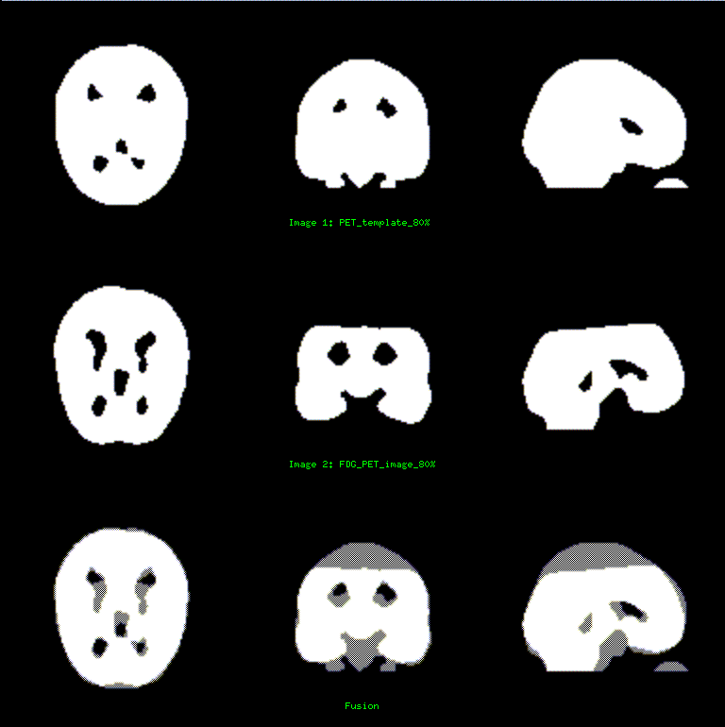

Figure 1:
Row 1: Binary mask of the PET template image thresholded for voxels >80% of mean
Row 2: Binary mask of the subject image co-registered to the template using Method 3, PET2PET linear, thresholded for voxels >80% of mean.
Row 3: Fusion of the Template and subject image in row 1 and 2. Gray voxels are discordant.
Voxel concordance of these images is 92.78%.

Results

Images were prepared and transformations applied using SPM96 [1]. Visual displays were prepared using the Multi-Purpose Imaging Tool, MPITool [5]. The measure of voxel concordance was obtained from the images using a MATLAB routine [6] developed by the authors.

Concordant sensitivity to system parameters

The concordant voxel method to determine goodness of fit was validated by performing a series of experiments and evaluating its performance in situations where we knew the answer.

Displacement in X

Table 1: Results of concordance with a PET blood flow template displaced in x direction from the matched position.

displacement in x in mm | percent concordance with the pet template
0 | 100.00
5 | 92.62
10 | 85.88
15 | 80.22

This result is also pictured in Figure 2 below.

Displacement in Y

Table 2: Results of concordance with a PET blood flow template displaced in y direction from the matched position.

displacement in y in mm | percent concordance with the pet template
0 | 100.00
5 | 96.42
10 | 93.05
15 | 89.96

Smoothing

Table 3: Results of concordance with an FDG image following 5,10,15, and 20 mm smoothing comparison with the same image smoothed to 10mm.

smoothing in mm | percent concordance
5mm | 97.49
10mm | 100.00
15mm | 96.92
20mm | 93.32

Pixel threshold

Table 4: Results of concordance with an FDG image following variation in setting the gray matter threshold as a percent of the gray matter mean.

gray matter threshold as a percent of mean brain pixel value | percent concordance
50 | 90.97
60 | 91.44
80 | 90.42
100  120 | 87.68  85.94

Study Results of Normalisation Methods

Having performed validation experiments on the concordance measure, we applied it to our experimental study. The results are shown in Table 5 .

Table 5: The percent concordance for the 5 methods of normalization for 8 schizophrenic subjects for each registration method.

subject | Method 1:  MRI2PET linear | Method 2:  MRI2PET non-linear | Method 3:  PET2PET linear | Method 4:  PET2PET non-linear | Method 5:  PET2PET nonlinear masked template
1 | 92.04 | 92.45 | 92.78 | 94.64 | 94.75
2 | 92.70 | 92.90 | 93.19 | 93.97 | 95.46
3 | 90.15 | 88.84 | 93.88 | 96.30 | 96.05
4 | 91.54 | 91.41 | 92.98 | 95.61 | 95.06
5 | 91.19 | 92.53 | 93.33 | 95.58 | 95.75
6 | 92.10 | 93.02 | 93.28 | 95,79 | 95.51
7 | 93.77 | 90.11 | 94.91 | 96.43 | 96.28
8 | 93.89 | 92.80 | 94.70 | 95.57 | 95.95
mean | 92.17 | 91.56 | 93.63 | 95.48 | 95.60

Statistical analysis

The null hypothesis was tested, that there is no significant difference in the degree of concordance provided by the five different methods we employed to achieve stereotactic normalisation. However, this null hypothesis was rejected, as a one way analysis of variance (ANOVA) with block design gives F(4,39)=23.4, p<.0001. There is a significant difference between the methods.

Post hoc test were performed on the study data. PET2PET non linear normalization produced the highest degree of concordance and was significantly higher than PET2PET linear (post hoc LSD, p<.006). There were no significant differences between the method using a masked vs. a total pet template. The MRI2PET non linear produced the least concordance and was significantly less than the PET2PET non linear and the PET2PET linear (post hoc LSD, p<.001)

Discussion

The new normalisation evaluation method, voxel concordance, was evaluated both visually and by simulation methods employing deliberate mis-matches. The evaluation process is illustrated in Figure 2. The first row shows three views (axial, coronal and saggital) of the PET.img template thresholded at 80% of the mean of the intensity of brain pixels. The second row shows the same image displaced by 10mm in the x-direction. The third row shows the fusion of these two images, where the discordant voxels are gray. From Table 1, the concordance of these images is 85.88%. We interpret this as a 85.88% match between these images. Tables 1 and 2 show that the concordance changes almost linearly with respect to the displacement in both x and y directions, which is a desirable trait for any performance measure.

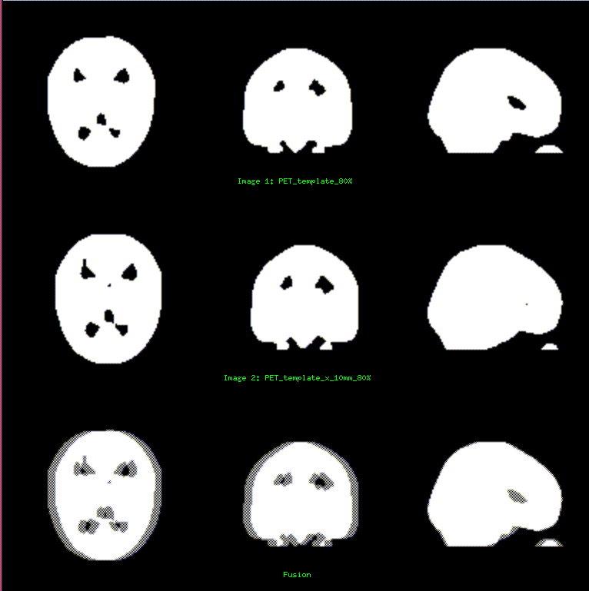

Figure 2.
Row 1: Binary mask of the PET template image thresholded for voxels >80% of mean
Row 2: Binary mask of the PET template displaced by 10mm in the x direction, thresholded for voxels >80% of mean.
Row 3: Fusion of the Template and the displaced template image in row 1 and 2. Gray voxels are discordant.
Voxel concordance of these images is 85.88%.
The most sensitive was the x displacement (almost 1.5% reduction in concordance per mm displaced) whereas a displacement of y by 5 mm reduces concordance by approximately 3%. This difference can be explained because of the elliptical shape of the brain.

The method was relatively insensitive to the gray matter threshold provided the thresholding was within a reasonable range approximating to the gray matter. Table 3 shows that a 20% change of threshold as percent of mean gives only 1.5% change in concordance.

Smoothing also had effects on the degree of concordance, as seen in Table 4. Smoothing by 5mm reduces concordance by approximately 3%, and again the measure responds linearly to changes in the smoothing kernel width.

These experiments serve to validate the measure as a useful measure of spatial normalisation accuracy.

Given that the evaluation method is valid, we applied it to a case study of 8 Schizophrenic subjects with multiple PET and MRI scans. We wish to determine the best method of spatial normalisation for these cases; Table 5 shows the concordance for each subject for each method. Figure 1 shows the concordance for patient 1 with the PET.img template using Method 3 (PET2PETlinear) with a gray-matter threshold of 80%. It can be seen that the subject’s ventricles are larger than the PET.img template ventricles, yielding a concordance of 92.78%..

Methods 3, 4, and 5 using the subjects’s image directly spatially normalized to the PET template were all superior to the methods using the MR image. This may be due to distortions in the MR images [ref personal communication Dr. A. MacKay] or due to limitations of SPM’s regristration algorithms. The MRI has significant distortions especially using the SPGR and other sequences up to 2-3 mm. From our results we know an increasing displacement in x or in y leads to a relative decrease in concordance. A 2mm distortion in the x-direction could explain the 3-4% discrepancy between methods using a MRI vs. PET template.

The best method overall was the PET2PET non-linear with the masked template (Method 5), though it did not differ significantly from the PET2PET non-linear (Method 4). However both these methods are limited in their use due to the truncated FOV in the PET data resulting in pulling of brain data towards the edges as shown in Figure 3.

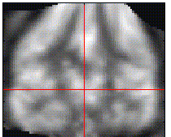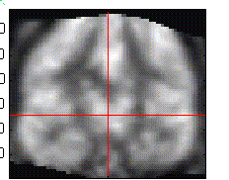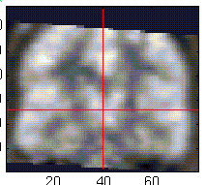

Figure 3. From left to right: PET2PET nonlinear (Method 4), PET2PET non linear with masked template (Method 5) and PET2PET linear (Method 3).
Therefore we chose PET2PET linear (Method 3) as the method for spatial normalization of subject PET images to standard space, as it resulted in the highest degree of concordance with the least aberration to the data.This finding is in accordance with others who have pointed out the difficulties in performing non-rigid body co-registrations [7].

Conclusions and Future Work

The new voxel concordant measure was very helpful in determining which spatial normalization method to use in our case study. However, visual evaluation of each method was still required to rule out aberrant transformations in incomplete data sets.

Despite the high concordance resulting from using an incomplete PET image registered to a complete or cropped template, care should be given when performing a warping to any data set with missing data. Edge effects (deformations) were noticeable (Figure 3) in two subjects when a non linear transformation was used regardless of the template (MRI, PET, PET masked). For this reason a PET2PET linear transformation was selected as the best method to spatially realign FDG-PET data into standard space.

Future work will include further studies on the rational for poor MRI spatial registration as defined by voxel concordance. These will include a further examination of the distortion of MRI relative to PET data and the use of other multi-model registration methods.

References

1. Statistical Parametric Mapping, The Wellcome Department of Cognitive Neurology, Ashburner J, Friston K, Holmes A, Poline JB. 1996. Also web site http://www.fil.ion.bpmf.ac.uk/spm/dox.html
2. Talairach P and Tournoux J. A stereotactic coplanar atlas of the human brain. Stuttgart;Thieme, (1988).
3. Fox PT, Perlmutter JS, Raichle. A stereotactic method of anatomical localization for positron emission tomography. J Comput Assist Tomogr 9:141-153 (1985).
4. Spinks TJ, Jones T, Bailey et al. Phys Med Biol 37,8 (1992) 1637-1655
5. Multi Purpose Imaging Tool MPITool, Advanced Tomovision, Gesellschaft fur Medizinische Bildverarbeitung mbH, Erftstadt, Germany. Version 2.57 (1998).
6. Matrix Laboratory MATLAB tool: /http://www.mathworks.com/products/matlab/
7. Zuk TD, Atkins MS. A comparison of Manual and Automatic Methods for Registering Scans of the Head. IEEE Transactions on medical Imaging. Vol, 15, no 5 732-744 (1996).

