Visual Presentation of Magnetic Resonance Images

J. E. van der Heyden, M. S. T. Carpendale, K. Inkpen, M. S. Atkins
School of Computing Science
Simon Fraser University
Burnaby, BC, V5A 1S6 Canada
+1 604 291 4277
{ heyden, carpenda, inkpen, stella }@cs.sfu.ca

ABSTRACT
Medical image analysis is shifting from current film-oriented light screen environments to computer environments that involve viewing and analyzing large sets of images on a computer screen. Magnetic Resonance Imaging (MRI) studies, in particular, can involve over 100 images. This paper examines how best to meet the needs of radiologists in a computational environment. To this end, a field study was conducted to observe radiologists’ interactions during MRI analysis in the traditional light screen environment. Key issues uncovered involve control over focus and context, dynamic grouping of images and retrieval of images and image groups. To address the problem of focus and context, existing layout adjustment and magnification techniques are explored to provide the most appropriate solution. Our interest is in combining the methodologies of human computer interaction studies with computational presentation possibilities to design a visual environment for the crucial field of medical image analysis.

KEYWORDS
health care, medical images, MRI image presentation, user interfaces, detail and context.

INTRODUCTION
There is currently an emphasis on shifting from the traditional film-oriented environment to digitized images suitable for viewing on computers. As Hospital Information Systems (HIS) become more common, it is natural to bring medical images on-line and include them with patient information. On line medical images can be viewed at separate locations simultaneous.
Medical imaging systems currently combine image processing and image presentation for diagnostic and consulting purposes. However, while image processing is well suited to the computer, image presentation remains a difficult problem. MRI analysis, in particular, commonly involves viewing between 60 and 120 images. The traditional light screen is large and well suited to this purpose (see figure 1) but presenting the same number of images on a much smaller computer screen remains a challenge. We explore radiologists’ interactions in the light screen environment, to understand the requirements for image presentation that best suit the MRI analysis process. General requirements are summarized and categorized. Computational solutions and tradeoffs for focus and context, are examined. Finally, a solution to the focus and context presentation problem is proposed.

Background
The traditional technology for displaying MRI images is the use of a large light screen panel (Figure 1). The panel used in the current study, consists of two visible screens each measuring 58″ × 19″. These are positioned one above the other to form a 58″ × 38″ display area. This total area is large enough to display eight MRI films where each film measures 14″ × 17″ and contains 15 to 20 images depending on image size and shape.
Images are logically grouped into volume sets of different planar orientation and contrast. Each set contains a number of sequential slices that combine to make the volume. These sets are distinguished by planar orientation (i.e. axial, saggital, coronal) or by tissue contrast. Contrast sets are determined at data acquisition time and differ in grey scale representations. This difference in “contrast” is an important factor in the identification of healthy and unhealthy tissue.
Figure 1:Light screen displaying MRI images.

EXPERIMENTAL METHOD
A field study was conducted at Vancouver Hospital to understand the MRI analysis process. Informal observations of radiologists interacting in a traditional film-oriented environment were gathered using researcher field-notes and videotape data. Observations were gathered during five one to two hour diagnostic teaching sessions involving both intern and staff radiologists. These sessions provide diagnosis for current MRI cases while at the same time providing a learning experience for intern radiologists. They progress very much like a non-teaching diagnostic situation, except
Figure 2:MR images using Propagating Minimal Scale variation
being they are slower and that there is more talking. They are exceptionally well suited to the observation task as the slower pace and helpful commentary clarifies the activities and thought processes of the team. Question and answer sessions were also conducted with the radiologists in order to better understand the nature of the images and diagnostic process.

FIELD OBSERVATIONS
Films are arranged according to logical groupings where appropriate and individual preference otherwise. Arrangement of the films cannot accommodate all aspects of the analyses and in a typical session there is a great deal of physical movement. The radiologists will stand up, sit down, and move to the left or to the right of the screen in order to focus on specific images or image groups. Pointing or sweeping hand motions are also used and can indicate areas of interest. Often radiologists point at one or more images for a prolonged period, marking them for comparison purposes or future reference. Films are sometimes moved to different locations or removed entirely, to obtain better grouping and context. At times an entire film may be extracted from the light screen and held up to the light by hand for closer viewing. In this manner, each session appears to progress in a similar fashion, with the frequency of movements varying from one radiologist to the other. The pattern of observations and comparisons made in each session, however, is unique and dependent on both the radiologist and the particular case.
Figure 3:MR images using Space Preserving variation

REQUIREMENTS
It is apparent from observations and discussions that all images are scanned at least once and several subgroups of images are singled out for simultaneous viewing or comparison purposes. As sub-groups may involve some of the same images, it is not possible to permanently position the films so that the components of each subgroup are close together. Radiologists typically solve this problem through physical movement or by reorganization of the films, obtaining multiple groupings of images as required. Although this method appears cumbersome, it allows radiologists complete control and flexibility with regard to which images they view up close, which images they view as a group and which image sets they scan as a whole.
Further examination of the observations and comments from the radiologists resulted in a list of individual actions and associated requirements. Although many of these overlap, in general three main categories of requirements emerged:
Grouping: Ability to dynamically group desired images together for simultaneous viewing and comparison. Provide flexible user control over the location and visibility of the groups on the screen.
Retrieval: Ability to locate and relocate both stored and visible images as well as stored and user determined groups of images. Provide visual clues and representations of available images and image groups in order to facilitate retrieval.
Focus and Context: Ability to view one or more images up close without losing or over lapping the remaining images in the group. Present individual image detail and related contextual images at the same time.
The first two categories, Grouping and Retrieval, are beyond the scope of this paper not covered here. The rest of the paper addresses the third, Focus and Context, requirement.

COMPUTATIONAL CHOICES
Research in computational presentation is examined in order to find an appropriate approach for medical imaging presentation that fulfills the focus and context requirement. The traditional light screen provides a large and flexible display space, while the computer screen limits the number of images that can be displayed effectively. Depending on the computer screen size, once the number of displayed images exceeds some maximum, the image size must be decreased and detail is lost.. Current systems rely on standard zooming and panning techniques in combination with large and, often multiple computer screens. Magnifying one image using standard zoom can recapture detail but sacrifices context. Increasing the available computer display space postpones the inevitable conflict between presenting detail and maintaining context but does not resolve it. Furthermore, large or multiple screens are expensive and often not an option for smaller hospitals or for use in remote consultation.
This problem indicates a need for a versatile layout and magnification strategy that makes maximum use of screen real estate and provides for both image detail and group context. To our knowledge, research in focus and context magnification techniques (also called fisheye and distortion) has not yet been applied to medical imaging presentation. We examine research in this area for a technique that suites the data involved in the current task.
There are several visual requirements originating from the nature of the data and the MRI analysis task. Though each image in itself represents medical data, the presentation problem requires laying out images as discrete objects. Also, while it is useful to provide
magnification of the images, no distortion other than scaling can be tolerated. In other words, the aspect ratio of the image must be maintained throughout any layout adjustments.
As sequential positioning of images in logical groups indicates a volume set of a particular planar orientation, maintenance of positioning information is also crucial. We interpret this as a need to preserve the orthogonality or left/right, up/down ordering of the layout. Orthogonality has been noted as playing an important role in preservation of the user’s mental map[misu94,
stor95]. From our observations we would like to enforce orthogonality in a manner that also preserves parallelism, or the alignment of the images, keeping image centers in a given row or column in a straight line.
Finally, the comparison aspect of the analysis task indicates that selection of more that one image, creating multiple focal views, is also important. Due to the sensitive nature of this task, it is further important that the focal images are presented with equal scale.
A great variety of distortion presentation techniques exist, varying from the single focal Bifocal Display [spen82] to powerful multi-focal presentations such as 3DPS [carp95] and Non-linear views as in [keah96] (for surveys see [leun94, noik94]). However, the orthogonality requirement greatly reduces this list. Early orthogonal approaches [misu94, sark94] had to be eliminated because they cause information distortion in the rows and columns that hold focal points and thus would distort the images themselves. The Zoom
family [bart95] introduces smooth interview transitions which also aid in preservation of the mental map but allows a more loose interpretation of orthogonality than would be ideal in this case. The ShriMP[stor95] approach comes the closest to fitting the observed requirements.

COMPUTATIONAL APPROACHES
The orthogonal version of ShriMP complies with most of the layout requirements described in the above section. It operates on discrete objects and thus allows images to remain as separate items. The individual objects are manipulated without distortion ensuring that the images themselves are not distorted. It also preserves orthogonal relationships in a manner that preserves parallelism.
SHriMP expands its focal node, pushes other nodes out of the display area to make space, then scales all nodes to once again fit into the area. Repeating this procedure over sequentially selected focal nodes results in each subsequent selection reducing the magnification of the previously selected focal nodes. Figure 4 shows this effect. One additional focal node is selected and expanded in each image. The variation in scale is apparent..
Figure 4: Varied scales of foci in sequential selection
We propose three multiple foci layout variations:
Propagating Minimal Scale. All magnification and expansion operations of the algorithm are completed before re-scaling. In this way sequential selection can be supported within the SHriMP approach. This approach best preserves orthogonality and parallelism but introduces the most white space. See figures 2 and 5.
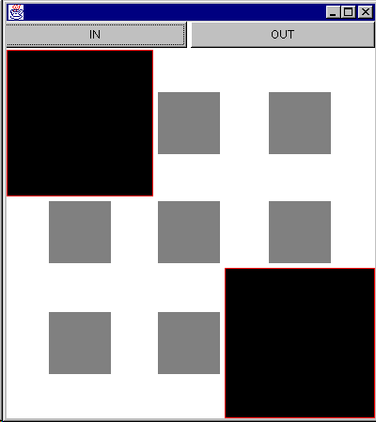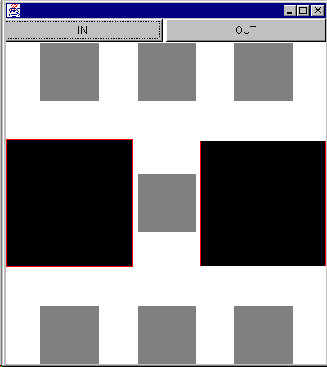
Figure 5: Propagating Minimal Scale
Constrained Areas. Rows and columns that hold established foci are eliminated from the adjustable space, and the previous focal node is prevented from being down-sized by the next selection. This approach results in a decrease of adjustable display space as some images approach their minimum size. It also introduces many inter-mediate levels of scale. However, it does allow subsequent foci to be set to equal scales. See figure 6.

Figure 6: Constrained Areas
Space Preserving. This approach performs adjustments by column, compressing as necessary down individual columns. The node at the intersection of a compressed row and column receives compression effect from both. This approach makes good use of space, preserves orthogonality, allows for sequential focal selection, but compromises parallelism. See figures 3 and 7.
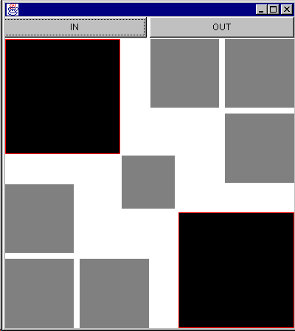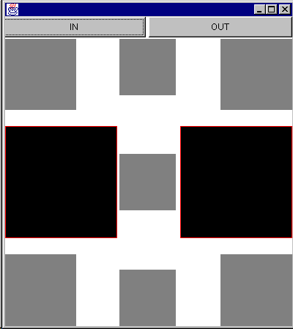
Figure 7: Space Preserving

CONCLUSION
Providing radiologists with functionality to support interactions similar to those currently utilized in the light screen environment will help ensure a more seamless transition to computerized medical image analysis. Three separate areas have been identified as general requirements that must be met in order to provide the radiologists with the same control as they are accustomed to with the light screen: retrieval, grouping and focus and context. Of these, the focus and context requirement was further examined. It was hypothesized that layout and fisheye magnification techniques would be better applied to this problem than traditional zooming, panning techniques. A solution was proposed and alternative resulting layouts suggested.
In order to determine the feasibility of the proposed solution, further user studies must be performed. A comparison study of the proposed alternative layouts will form the basis of one of these,. A prototype has also been implemented for the purpose of further response from the radiologists. Further work is also required to integrate retrieval and grouping techniques in order to satisfy the remaining general requirements

ACKNOWLEDGMENTS
We thank the radiologists at Vancouver Hospital, David Li, Boris Flak, Bruce Forster, Benjamin Wong and Jay Barberie for their participation, without which this study would not have been possible. Their time, patience and sense of humor throughout, was greatly appreciated.

REFERENCES
- [leun94] Leung Y. K., A review and taxonomy of distortion-oriented presentation techniques., ACM Transactions on Computer-Human Interaction, Vol. 1, No. 2, June 1994, 126-160.
- [misu94] Misue K., Eades P., Lai W., Sugiyama K., Layout Adjustment and the Mental Map., Journal of Visual Languages and Computing,, Vol. 6, No. 2, 1995 183-210.
- [noik94] Noik E. G., A space of presentation emphasis techniques for visualizing graphs., Graphic Interface, 1994.
- [bart95] L. Bartram, A. Ho , J. Dill and F. Henigman. The Continuous Zoom: A Contstrained Fisheye Technique for Viewing and Navigating Large Information Spaces., ACM Press, UIST'95: Proceedings of the ACM Symposium on User Interface Software and Technology, 1995, 207 - 216.
- [carp95] M. S. T. Carpendale, D. J. Cowperthwaite and F. D. Fracchia. 3-Dimensional Pliable Surfaces: For Effective Presentation of Visual Information. ACM Press, Proceedings of the ACM Symposium on User Interface, 1995.
- [sark94] M. Sarkar, S. Snibbe and O. J. Tversky and S. P. Reiss. Stretching the rubber sheet: A metaphor for viewing large layouts on small screens. UIST: Proceedings of the ACM Symposium on User Interface Software and Technology, 1993, 81-91.
- [sark93] M. Sarkar and M. H. Brown. Graphical Fisheye Views., Communications of the ACM, Vol. 37, No. 12, 1994, 73-84.
- [spen82] R. Spence Vand M. Apperly. Data base navigation: an office enviroment for the professional., Behaviour and Information Technology, Vol. 1, No. 1,1882, 43-54.
- [stor95] M. A. Storey and H. A. Muller. Graph Layout Adjustment Strategies., Graph Drawing '95, 1995, 487-499.
- [keah96] T. A. Keahey, E.L. Robertson. Techniques for Non-Linear Magnification Transformation in Proceedings of IEEE Information Visualization Symposium, 1996, .38-45.

